Comparison of different peak detector circuits
The goal is to achieve reliable detection on 100kHz pulses in voltage range of 1mV to 1V. Architecture of the detector is chose to be precision rectifier → capacitor for peak hold and relaxation → RC filter to filter out rectification noise.
Upper circuit – half wave rectifier
Lower circuit – full wave rectifier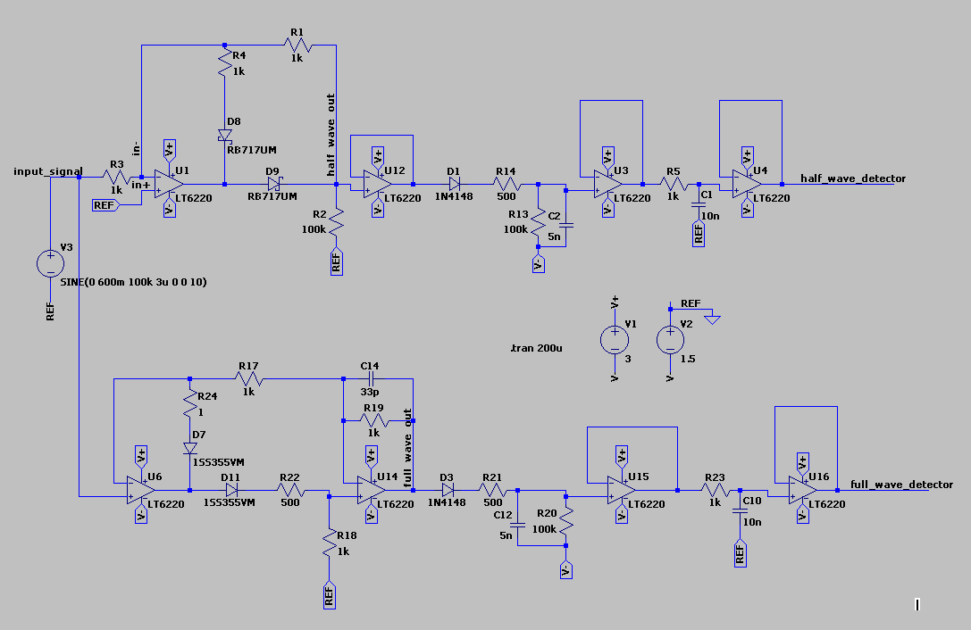

Analysis of rectifier circuits

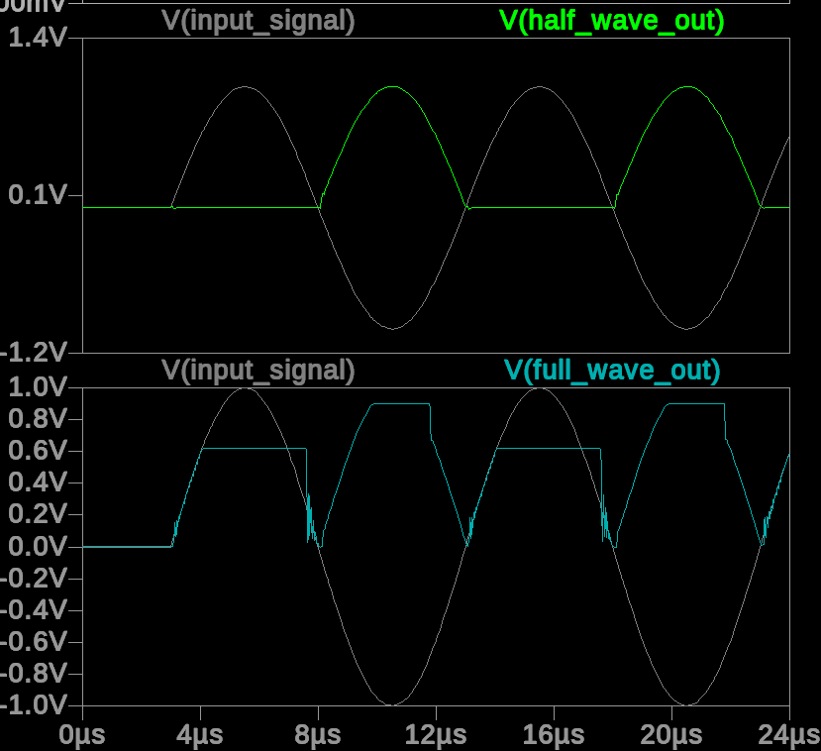
At 1V full-wave rectifier is saturated and the output signal is distorted

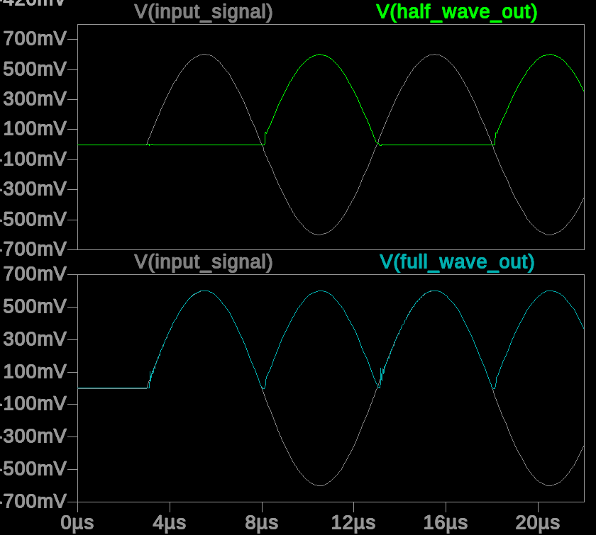
At 600mV both circuits operate normally, this is the upper limit for full-wave rectifier

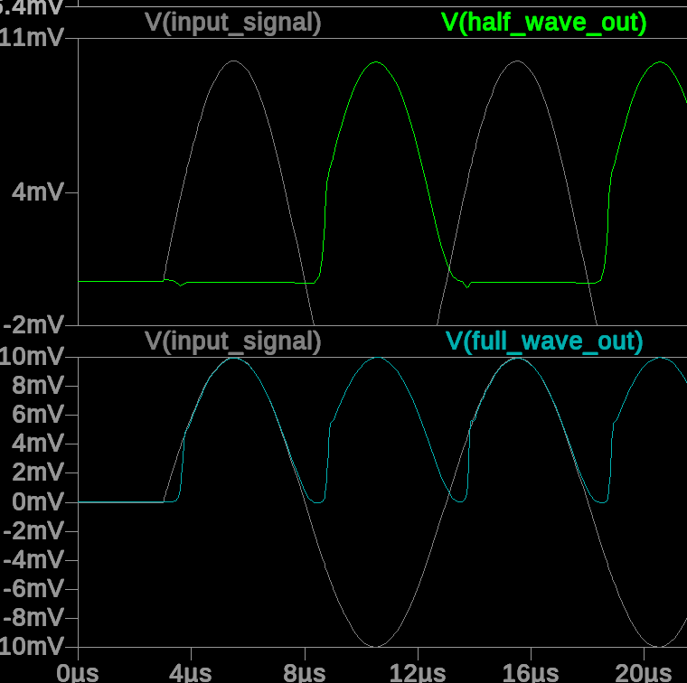
At 10mV input output is distorted at the start of signal swing but the amplitude of the signal is the same as an input in both cases.
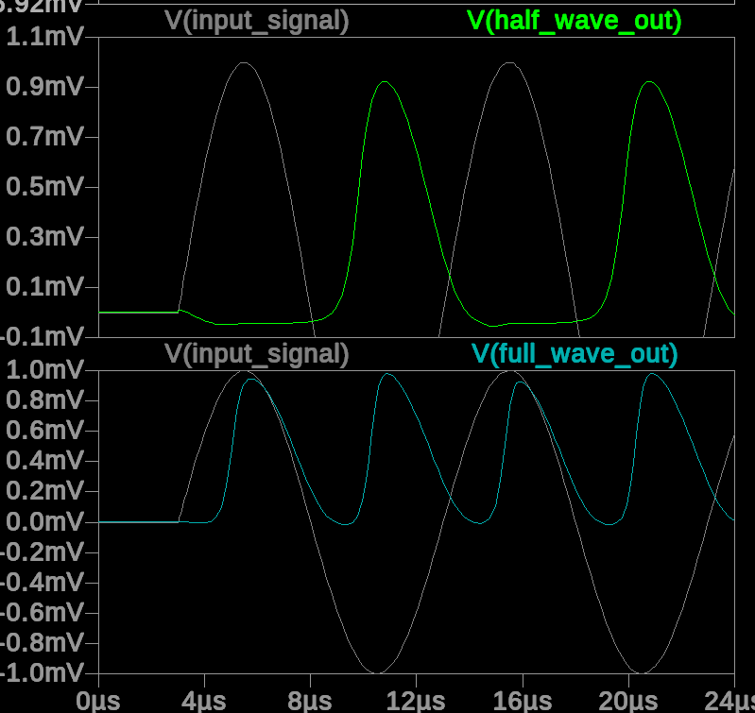
At 1mV signal is distorted and amplitude of the output is around 5% lower than the input

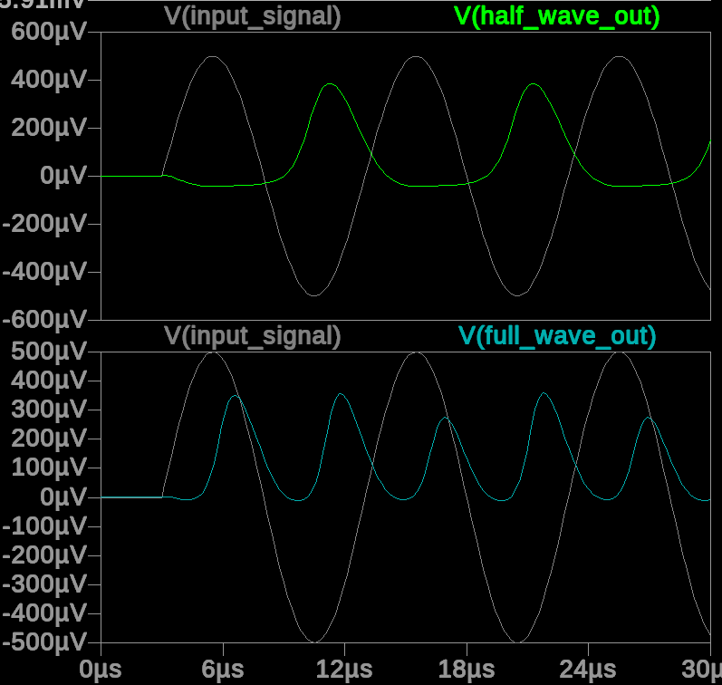
At 0.5mV signal is distorted in both cases, but full wave rectifier has higher RMS. This is the lowest detectable voltage for both circuits.

Analysis of peak detector circuits
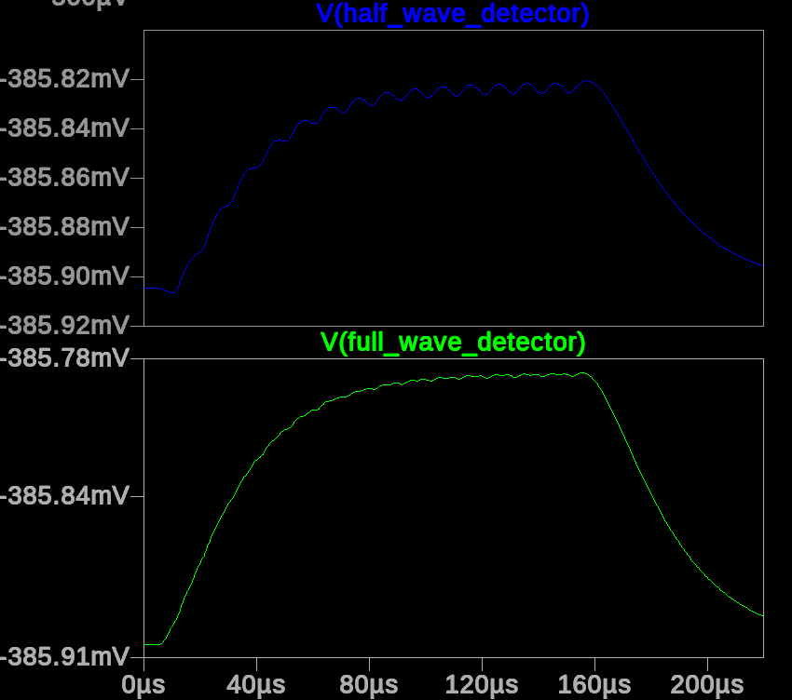
At 0.5mV input signal both peak detectors has around 0.1mv output, and ripple is present in half wave detector

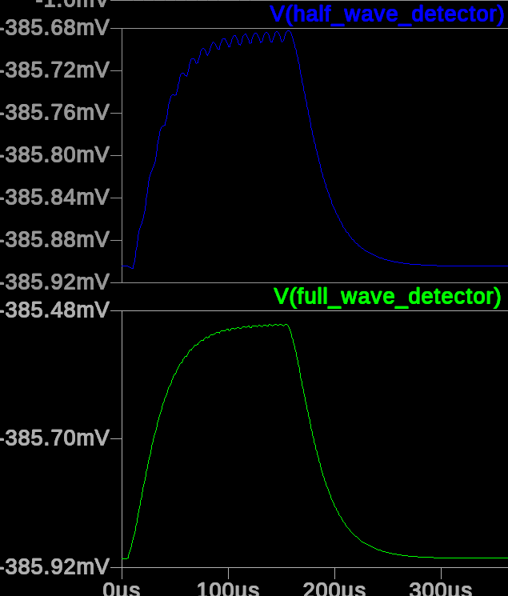
At 1mV input full-wave peak detector have 0.4mV amplitude, half wave have 0.2mV

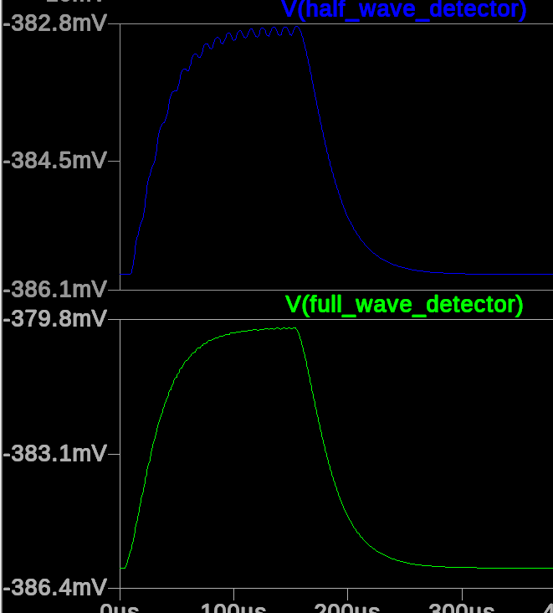
At 10mV input full-wave output is 6mv, half-wave is 4mV

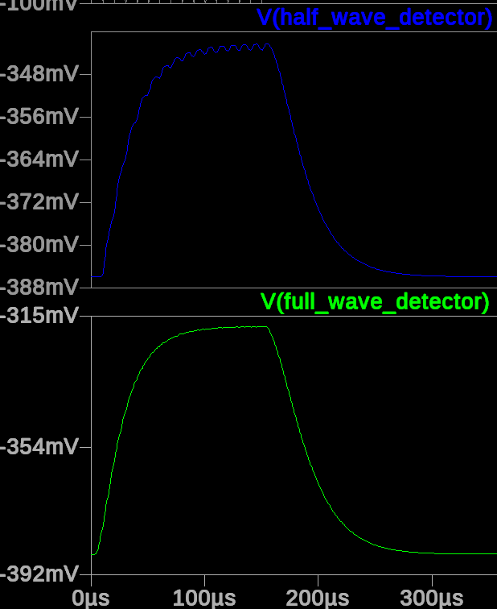
At 100mV input full-wave output is 60mV, half-wave is 40mV

Conclusion hh
Both circuits perform well enough to be used as a peak detector. The dynamic range of both circuits is about 55dB. There was some issues with oscillatiions and ringing in feedback circuits. To reliably detect low voltage output of the detector additional 16bit ADC is needed. The risks are that the real circuit can perform worse than the simulation. The peak detector requires precision OPAMP and ADC. To register low power signals it would be better to use AD8304 logarithmic converter with high dynamic range of 160dB, and output can be connected to built-in 12bit ADC of the target MCU to detect signals in very broad range. AD8304 has the cost comparable to ADC + quad OPAMP and better quality. For prototype stage it is better to evaluate both peak detector and AD8304.

